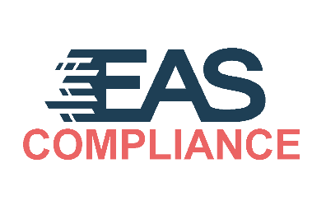**EAS EU compliance Woocommerce plugin**

**Version 1.0**

## User Guide

### Overview

EAS EU compliance (EAScompliance) is extension for WooCommerce that enables buyers from EU countries to calculate and pay customs duties and VAT.

EAS EU compliance tracks latest data on EU customs codes taxation rates and allows seamless calculation, declaration and payment of customs duties during items checkout process.

EAS EU compliance main features are:

- keep track of HSCODE, originating country and other necessary customs attributes in WooCommerce products registry.

- offer customs duties and VAT calculation during checkout for purchases shipped to EU countries

- combine product and user data necessary for customs duties and VAT payment and calculate current customs duties for goods to be purchases

- include customs duties into WooCommerce Order and transfer customs duties and VAT payment to EU Tax system.

### Installation

You can install plugin manually or via WooCommerce marketplace.

**Manual installation.**

1. Download zip archive from that link.
2. Open administrators Dashboard of your WooCommerce instance.
3. Navigate to Plugins → Add new. 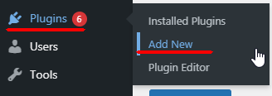
4. In the window press button “Upload plugin”

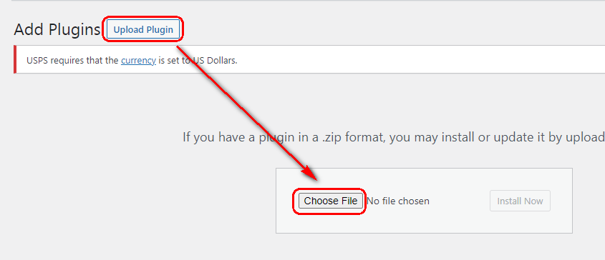

1. Press button “Choose File”.
2. Select previously downloaded file (EAScompliance.zip).
3. Press button “Install now”

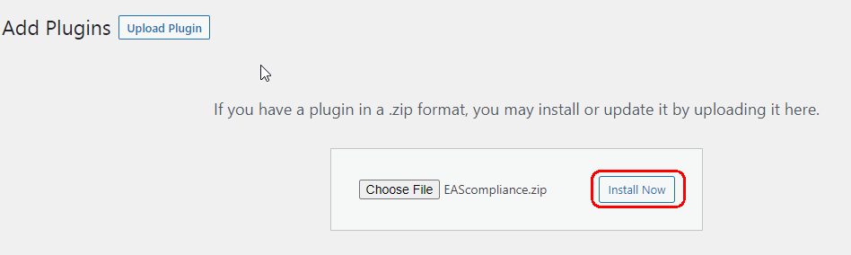

1. Once installation finished, press button “Activate plugin”

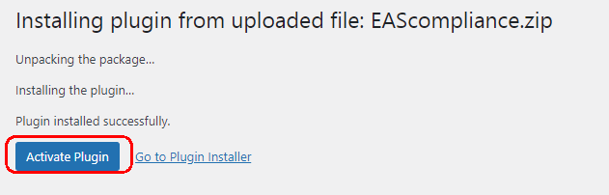

1. Installation finished. Plugin to be configured, please follow to configuration section of plugin.

**Installation from WooCommerce marketplace**

Extension is available for download at WooCommerce marketplace:

<https://woocommerce.com/product-category/woocommerce-extensions/marketing-extensions/>

Please reference WordPress plugin installation documents to install EAScompliance plugin:

<https://www.wpbeginner.com/beginners-guide/step-by-step-guide-to-install-a-wordpress-plugin-for-beginners/>

### Plugin Configuration

Upon enabling plugin, “EAS EU compliance” settings page will be available in WooCommerce → Settings → EAS EU compliance tab:

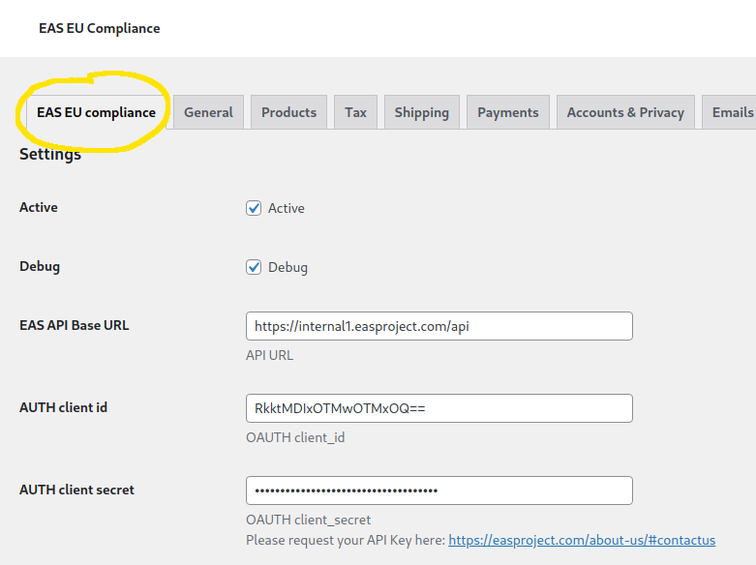

Sign up with EAS Project to obtain connection URL and authorization keys:

https://easproject.com/about-us/#contactus

In the ‘Shipping methods by post’ check all delivery options that can be considered as Postal delivery. That information will be used in landed cost calculation process.

Check product attributes that will be created after saving changes.

Check ‘Activate’ and press ‘Save changes’ to test connection with API and create necessary product attributes.

If wrong credential where provided Plugin won’t activate and error message will be displayed.

Newly created product attributes should be added and filled for each selling product in the store.

Values of additional attributes influences on the VAT and customs duties values.

If in attributes “Warehouse country”, “Seller registration country” and “Originating country” not filled then registration country of the shop (configured in Woocommerce instance) will be used instead.

**Notice!**

To assign values for additional attributes follow next steps for each product in the products section of your store:

1. Select “Attributes” section on the left menu of the product.
2. From the drop down control “Custom product attribute”,
3. Press button Add.
4. In the field “Select Items” choose proper value.

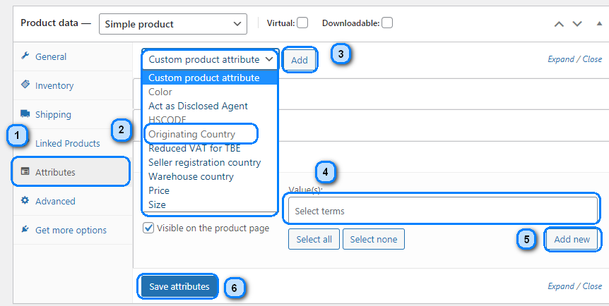

1. For some attributes you can create your own values by pressing button Add new.
2. Once finished with adding all attributes press button “Save attributes”

### Product attributes description

|  |  |  |
| --- | --- | --- |
| Attribute name | Description | Comments |
| Act as Disclosed Agent | This attribute should be filled for products that are sold as Disclosed agent. By default plugin will set to NO. | This attribute is applicable to customers that can be considered as Electronic Interface as per <https://ec.europa.eu/taxation_customs/business/vat/online-electronic-interfaces_en> |
| HSCODE | This attribute is used to store customs Harmonized system codes for products.  If no code is provided EAS backend will classify product using AI mechanism. | Codes can be found here <https://www.tariffnumber.com/> |
| Originating Country | To be populated with country where product was produced. This attribute influences on the proper Customs Duty rate selection. |  |
| Reduced VAT for TBE | If customer sell TBE and those TBE are considered as Reduced VAT TBE then need to set YES in that attribute. | TBE is described <https://ec.europa.eu/taxation_customs/business/vat/telecommunications-broadcasting-electronic-services/content/what-are-tbe-services_en> |
| Seller registration country | This attribute to be populated when ‘Act as Disclosed Agent” set to Yes. Need to select country of a seller who actually sell the product. If this attribute is not filled registration country on the shop will be used. |  |
| Warehouse country | To be populated with country where goods are actually sold from or delivery starts. |  |

### Using EAS EU compliance plugin

Users may add products to cart normally and proceed to Checkout.

When shipping country selected and it is EU country, button ‘Calculate Customs Duties’ is shown below cart total:

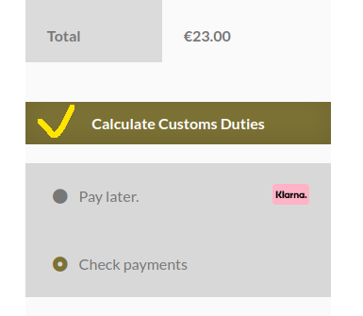

Pressing ‘Calculate Customs Duties’ collects cart and shipping information and sends user to EAS Confirmation page.

ON that page, depending on applicable sell schemes users need to fill some data and confirm calculation results by pressing “Confirm” button.

After Confirmation, user is redirected back to Checkout page and ‘Place Order’ button appears.

User can select preferable payment method and proceed to payment step.

After order was placed, changes of payment status from Pending to Processing will notify EAS API on paid order.

### Troubleshooting

Please provide Your feedback and issues found to [woocommerce@easproject.org](mailto:woocommerce@easproject.org)